ACS 54500 Cryptography and Network Security

Lab 5: Linux Firewall Exploration Lab

**Name:** Vijayagiridharan Subramanian

Note: For Task 1.B Task 1, please use “8.8.4.4”, instead of “8.8.8.8” as Google's DNS server.

Moreover, for Task 1.B. Task 2, “NF_INET_FORWARD” can be difficult to observe in a container environment and can thus be ignored.

**Task 1 Implementing a Simple Firewall– 60 pts**

**Task 1.A Implement a Simple Kernel Module – 10 pts**

**Code:**

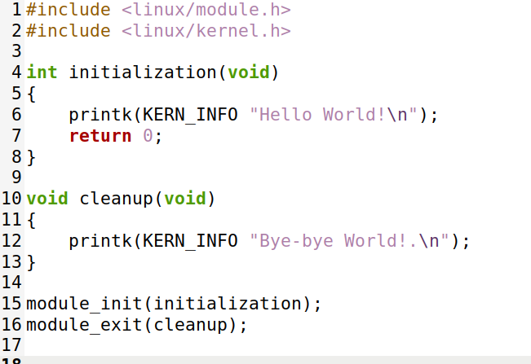

List all kernel modules

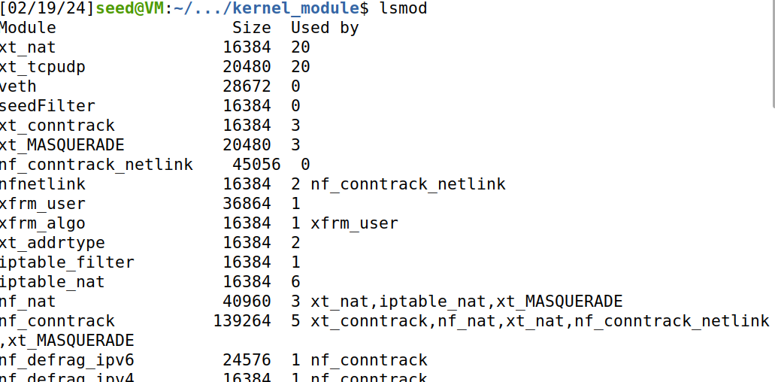

Dmesg displays all messages.

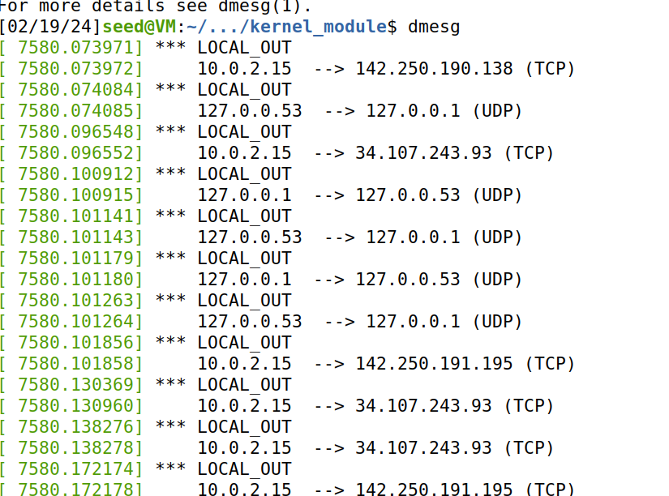

Inserting the kernel module using command **sudo insmod hello.ko**

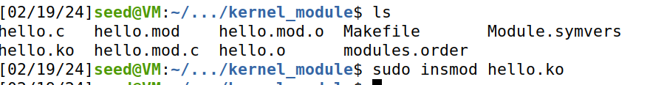

After inserting the kernel module “Hello world” message is displayed which shows module is loaded.

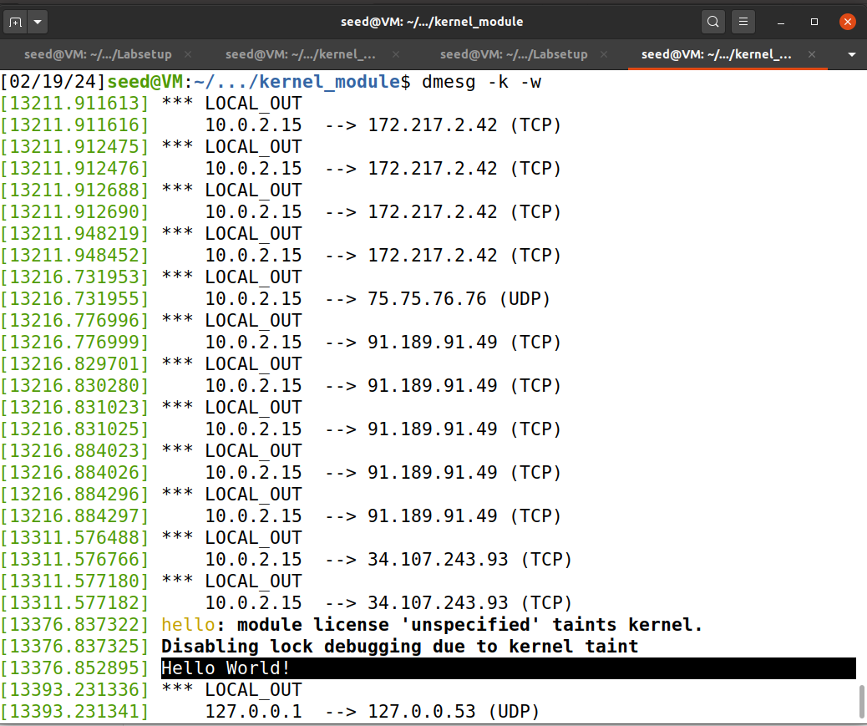

We can find hello module in the list.

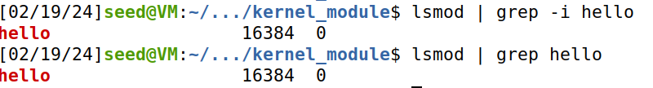

Now we are removing the module and checking whether it is there or not.



Then “Bye_bye World!” message is displayed in the kernel buffer.

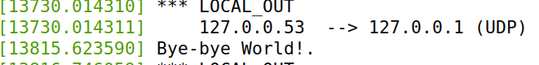

Below shows information about Linux kernel module

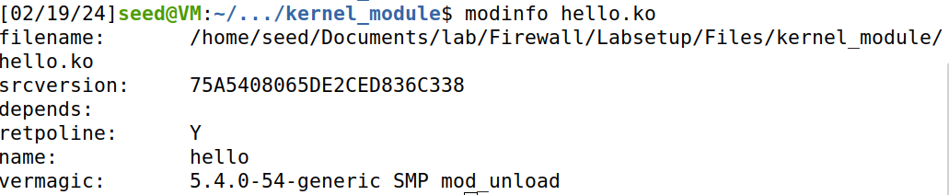

**Task 1.B Implement a Simple Firewall Using Netfilter– 10 + 10 + 30 = 50 pts**

Code:

#include <linux/kernel.h>

#include <linux/module.h>

#include <linux/netfilter.h>

#include <linux/netfilter_ipv4.h>

#include <linux/ip.h>

#include <linux/tcp.h>

#include <linux/udp.h>

#include <linux/icmp.h>

#include <linux/if_ether.h>

#include <linux/inet.h>

static struct nf_hook_ops hook1, hook2;

unsigned int blockUDP(void *priv, struct sk_buff *skb,

const struct nf_hook_state *state)

{

struct iphdr *iph;

struct udphdr *udph;

u16 port = 53; //DNS

char ip[16] = "8.8.4.4";

u32 ip_addr;

if (!skb) return NF_ACCEPT;

iph = ip_hdr(skb);

// Convert the IPv4 address from dotted decimal to 32-bit binary

in4_pton(ip, -1, (u8 *)&ip_addr, '\0', NULL);

if (iph->protocol == IPPROTO_UDP) {

udph = udp_hdr(skb);

if (iph->daddr == ip_addr && ntohs(udph->dest) == port){

printk(KERN_WARNING "*** Dropping %pI4 (UDP), port %d\n", &(iph->daddr), port);

return NF_DROP;

}

}

return NF_ACCEPT;

}

unsigned int printInfo(void *priv, struct sk_buff *skb,

const struct nf_hook_state *state)

{

struct iphdr *iph;

char *hook;

char *protocol;

switch (state->hook){

case NF_INET_LOCAL_IN: hook = "LOCAL_IN"; break;

case NF_INET_LOCAL_OUT: hook = "LOCAL_OUT"; break;

case NF_INET_PRE_ROUTING: hook = "PRE_ROUTING"; break;

case NF_INET_POST_ROUTING: hook = "POST_ROUTING"; break;

case NF_INET_FORWARD: hook = "FORWARD"; break;

default: hook = "IMPOSSIBLE"; break;

}

printk(KERN_INFO "*** %s\n", hook); // Print out the hook info

iph = ip_hdr(skb);

switch (iph->protocol){

case IPPROTO_UDP: protocol = "UDP"; break;

case IPPROTO_TCP: protocol = "TCP"; break;

case IPPROTO_ICMP: protocol = "ICMP"; break;

default: protocol = "OTHER"; break;

}

// Print out the IP addresses and protocol

printk(KERN_INFO " %pI4 --> %pI4 (%s)\n",

&(iph->saddr), &(iph->daddr), protocol);

return NF_ACCEPT;

}

int registerFilter(void) {

printk(KERN_INFO "Registering filters.\n");

hook1.hook = printInfo;

hook1.hooknum = NF_INET_LOCAL_OUT;

hook1.pf = PF_INET;

hook1.priority = NF_IP_PRI_FIRST;

nf_register_net_hook(&init_net, &hook1);

hook2.hook = blockUDP;

hook2.hooknum = NF_INET_POST_ROUTING;

hook2.pf = PF_INET;

hook2.priority = NF_IP_PRI_FIRST;

nf_register_net_hook(&init_net, &hook2);

return 0;

}

void removeFilter(void) {

printk(KERN_INFO "The filters are being removed.\n");

nf_unregister_net_hook(&init_net, &hook1);

nf_unregister_net_hook(&init_net, &hook2);

}

module_init(registerFilter);

module_exit(removeFilter);

MODULE_LICENSE("GPL");

**Make Command for SeedFilter:**

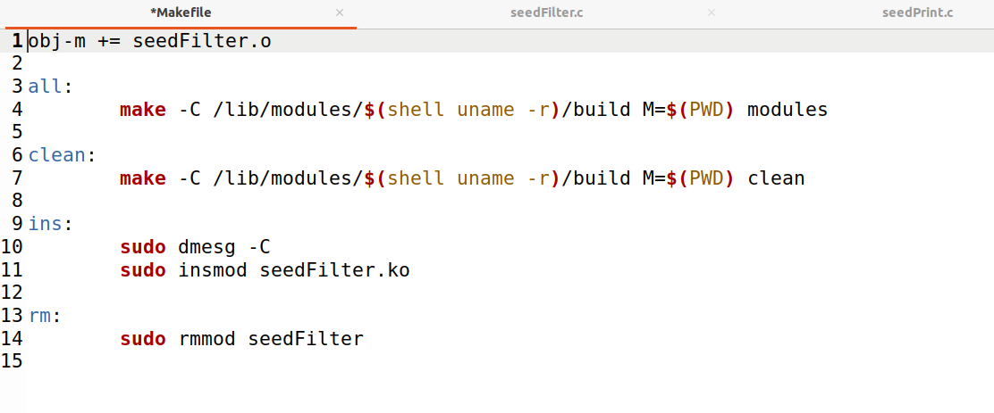

1 **Compile the sample code using the provided Makefile**

We are pinging [www.example](http://www.example).com and then trying with dig@8.8.8.8 but it is showing connection timeout and no server found. so, I am using 8.8.4.4

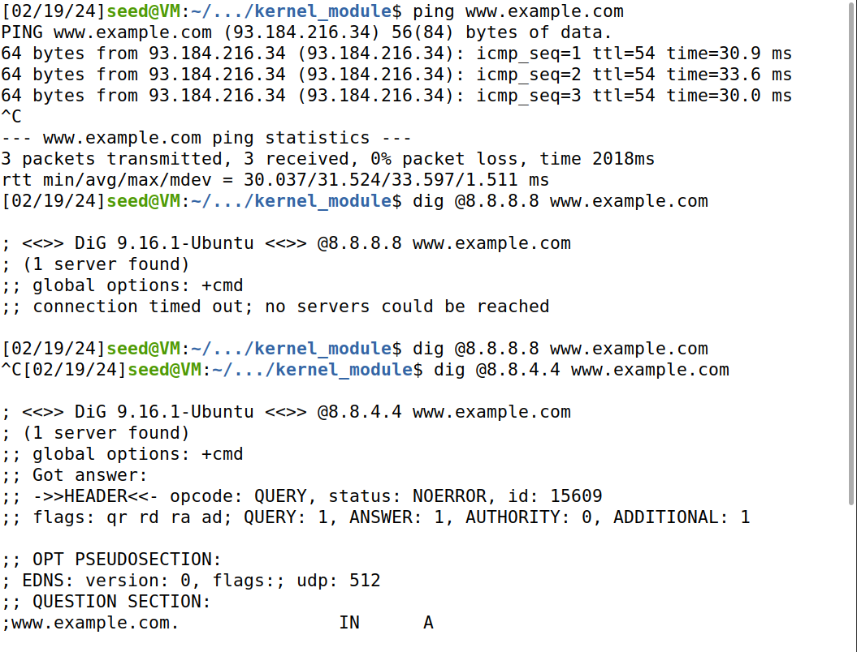

Now we can see highlighted kernel module is created using **make** command and is inserted. **Sudo insmod seedFilter.ko** inserts module and **lsmod| grep -i seed** used to see the existing seedFilte.

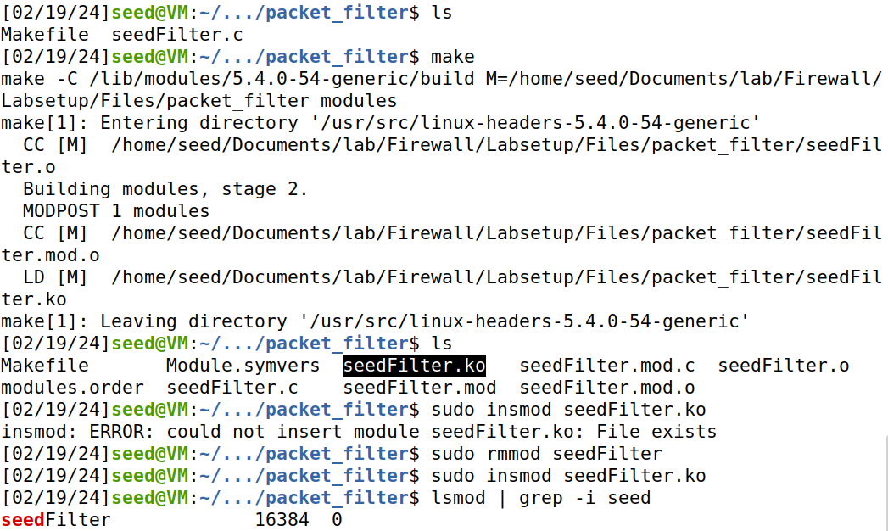

Registering Filters is displayed when **dmesg -k -e** command is entered which shows filtered is registered. UDP packets are generated

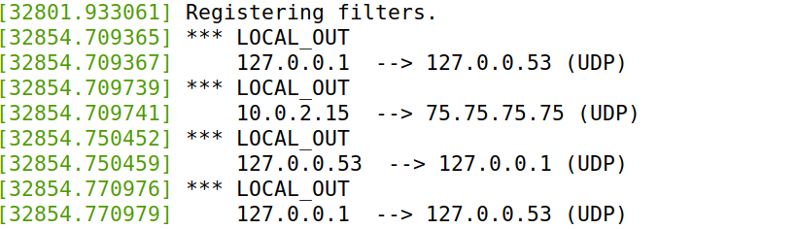

One more time when I run dig @8.8.4.4 [www.example.com](http://www.example.com), Dropping is displayed in message in dmesg -k -e. Which shows it works as expected.

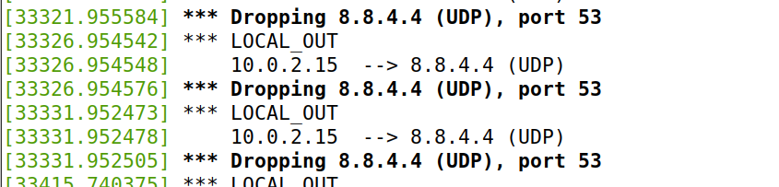



**2 Hook the printInfo function to all of the netfilter hooks.**

**Code:**

#include <linux/kernel.h>

#include <linux/module.h>

#include <linux/netfilter.h>

#include <linux/netfilter_ipv4.h>

#include <linux/ip.h>

#include <linux/tcp.h>

#include <linux/udp.h>

#include <linux/icmp.h>

#include <linux/if_ether.h>

#include <linux/inet.h>

static struct nf_hook_ops hook1, hook2, hook3, hook4, hook5;

unsigned int blockUDP(void *priv, struct sk_buff *skb,

const struct nf_hook_state *state)

{

struct iphdr *iph;

struct udphdr *udph;

u16 port = 53; //DNS

char ip[16] = "8.8.4.4";

u32 ip_addr;

if (!skb) return NF_ACCEPT;

iph = ip_hdr(skb);

// Convert the IPv4 address from dotted decimal to 32-bit binary

in4_pton(ip, -1, (u8 *)&ip_addr, '\0', NULL);

if (iph->protocol == IPPROTO_UDP) {

udph = udp_hdr(skb);

if (iph->daddr == ip_addr && ntohs(udph->dest) == port){

printk(KERN_WARNING "*** Dropping %pI4 (UDP), port %d\n", &(iph->daddr), port);

return NF_DROP;

}

}

return NF_ACCEPT;

}

unsigned int printInfo(void *priv, struct sk_buff *skb,

const struct nf_hook_state *state)

{

struct iphdr *iph;

char *hook;

char *protocol;

switch (state->hook){

case NF_INET_LOCAL_IN: hook = "LOCAL_IN"; break;

case NF_INET_LOCAL_OUT: hook = "LOCAL_OUT"; break;

case NF_INET_PRE_ROUTING: hook = "PRE_ROUTING"; break;

case NF_INET_POST_ROUTING: hook = "POST_ROUTING"; break;

case NF_INET_FORWARD: hook = "FORWARD"; break;

default: hook = "IMPOSSIBLE"; break;

}

printk(KERN_INFO "*** %s\n", hook); // Print out the hook info

iph = ip_hdr(skb);

switch (iph->protocol){

case IPPROTO_UDP: protocol = "UDP"; break;

case IPPROTO_TCP: protocol = "TCP"; break;

case IPPROTO_ICMP: protocol = "ICMP"; break;

default: protocol = "OTHER"; break;

}

// Print out the IP addresses and protocol

printk(KERN_INFO " %pI4 --> %pI4 (%s)\n",

&(iph->saddr), &(iph->daddr), protocol);

return NF_ACCEPT;

}

int registerFilter(void) {

printk(KERN_INFO "seedPrint: Registering filters.\n");

//NF_INET_PRE_ROUTING

hook1.hook = printInfo;

hook1.hooknum = NF_INET_PRE_ROUTING;

hook1.pf = PF_INET;

hook1.priority = NF_IP_PRI_FIRST;

nf_register_net_hook(&init_net, &hook1);

//NF_INET_LOCAL_IN

hook2.hook = printInfo;

hook2.hooknum = NF_INET_LOCAL_IN;

hook2.pf = PF_INET;

hook2.priority = NF_IP_PRI_FIRST;

nf_register_net_hook(&init_net, &hook2);

//NF_INET_FORWARD

hook3.hook = printInfo;

hook3.hooknum = NF_INET_FORWARD;

hook3.pf = PF_INET;

hook3.priority = NF_IP_PRI_FIRST;

nf_register_net_hook(&init_net, &hook3);

//NF_INET_LOCAL_OUT

hook4.hook = printInfo;

hook4.hooknum = NF_INET_LOCAL_OUT;

hook4.pf = PF_INET;

hook4.priority = NF_IP_PRI_FIRST;

nf_register_net_hook(&init_net, &hook4);

//NF_INET_POST_ROUTING

hook5.hook = printInfo;

hook5.hooknum = NF_INET_POST_ROUTING;

hook5.pf = PF_INET;

hook5.priority = NF_IP_PRI_FIRST;

nf_register_net_hook(&init_net, &hook5);

return 0;

}

void removeFilter(void) {

printk(KERN_INFO "seedPrint: The filters are being removed.\n");

nf_unregister_net_hook(&init_net, &hook1);

nf_unregister_net_hook(&init_net, &hook2);

nf_unregister_net_hook(&init_net, &hook3);

nf_unregister_net_hook(&init_net, &hook4);

nf_unregister_net_hook(&init_net, &hook5);

nf_unregister_net_hook(&init_net, &hook2);

}

module_init(registerFilter);

module_exit(removeFilter);

MODULE_LICENSE("GPL");

**Make file for seedPrint:**

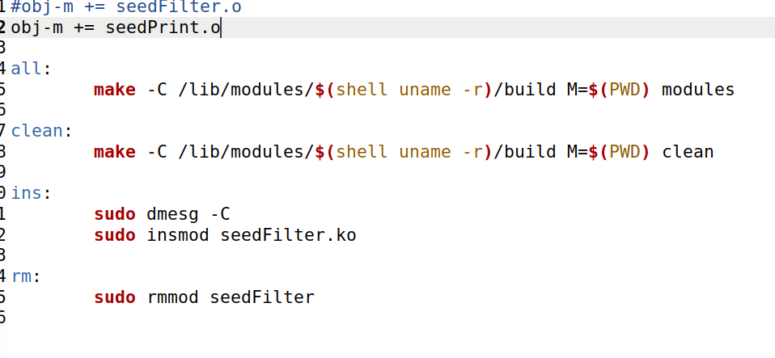

We are running make to build modules and we are inserting kernel module **seedPrint.ko** and registering filters message is displayed while running **dmesg -k -e**

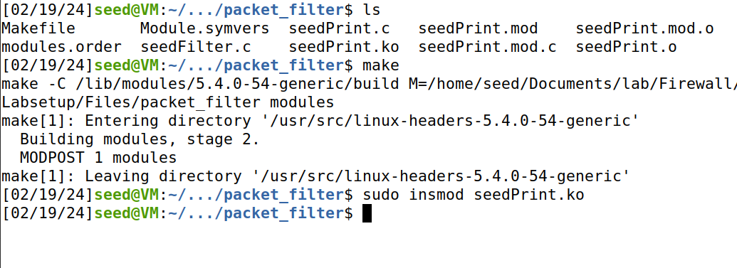

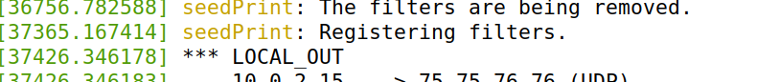

Once we enter **dig @8.8.4.4 www. example.com, in the kernel_module,** we can see Prerouting, LocalIn,Localout , This shows in this condition the hook functions are invoked.

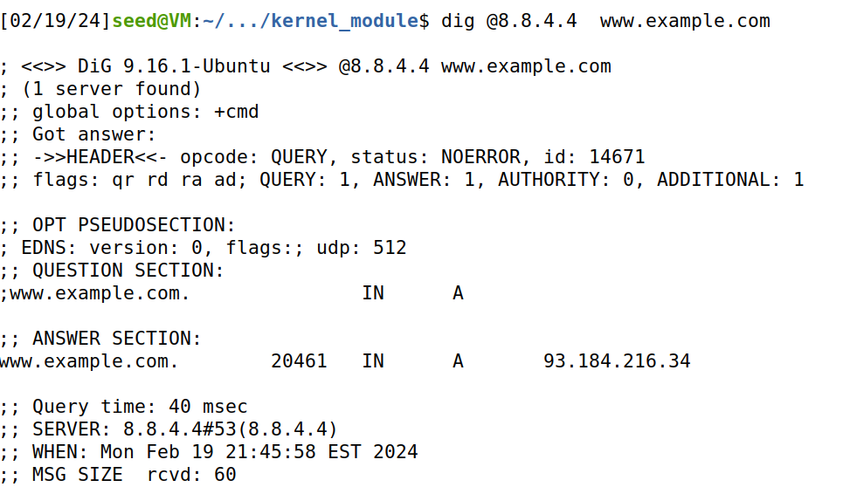

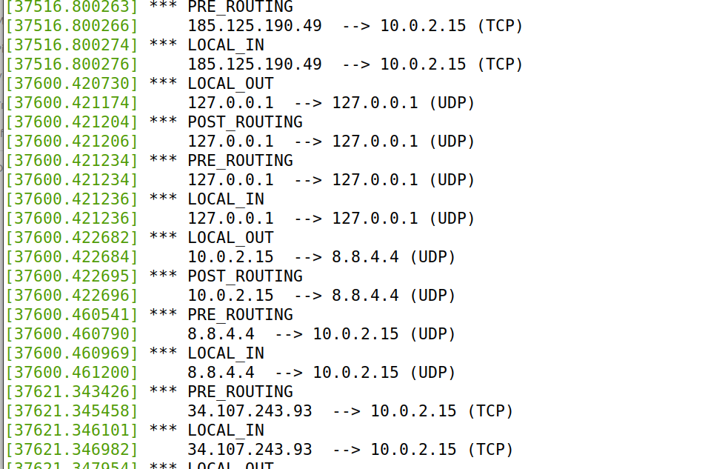

**3 Implement two more hooks to achieve the following:**

**Code:**

#include <linux/kernel.h>

#include <linux/module.h>

#include <linux/netfilter.h>

#include <linux/netfilter_ipv4.h>

#include <linux/ip.h>

#include <linux/tcp.h>

#include <linux/udp.h>

#include <linux/icmp.h>

#include <linux/if_ether.h>

#include <linux/inet.h>

static struct nf_hook_ops hook1, hook2, hook3, hook4;

//blocking udp to 8.8.4.4:53

unsigned int blockUDP(void *priv, struct sk_buff *skb,

const struct nf_hook_state *state)

{

struct iphdr *iph;

struct udphdr *udph;

u16 port = 53; //DNS

char ip[16] = "8.8.4.4";

u32 ip_addr;

if (!skb) return NF_ACCEPT;

iph = ip_hdr(skb);

// Convert the IPv4 address from dotted decimal to 32-bit binary

in4_pton(ip, -1, (u8 *)&ip_addr, '\0', NULL);

if (iph->protocol == IPPROTO_UDP) {

udph = udp_hdr(skb);

if (iph->daddr == ip_addr && ntohs(udph->dest) == port){

printk(KERN_WARNING "*** Dropping %pI4 (UDP), port %d\n", &(iph->daddr), port);

return NF_DROP;

}

}

return NF_ACCEPT;

}

//blocking ping to vm: 10.9.0.1

unsigned int blockICMP(void *priv, struct sk_buff *skb,

const struct nf_hook_state *state)

{

struct iphdr *iph;

struct icmphdr *icmph;

//u16 port = 53; //DNS

char ip[16] = "10.9.0.1";

u32 ip_addr;

if (!skb) return NF_ACCEPT;

iph = ip_hdr(skb);

// Convert the IPv4 address from dotted decimal to 32-bit binary

in4_pton(ip, -1, (u8 *)&ip_addr, '\0', NULL);

if (iph->protocol == IPPROTO_ICMP) {

icmph = icmp_hdr(skb);

if (iph->daddr == ip_addr && icmph->type == ICMP_ECHO){

printk(KERN_WARNING "*** Dropping destination %pI4 (ICMP)\n", &(iph->daddr));

return NF_DROP;

}

}

return NF_ACCEPT;

}

//blocking telnet to vm: 10.9.0.1:23

unsigned int blockTelnet(void *priv, struct sk_buff *skb,

const struct nf_hook_state *state)

{

struct iphdr *iph;

struct tcphdr *tcph;

u16 port = 23; //telnet

char ip[16] = "10.9.0.1";

u32 ip_addr;

if (!skb) return NF_ACCEPT;

iph = ip_hdr(skb);

// Convert the IPv4 address from dotted decimal to 32-bit binary

in4_pton(ip, -1, (u8 *)&ip_addr, '\0', NULL);

if (iph->protocol == IPPROTO_TCP) {

tcph = tcp_hdr(skb);

if (iph->daddr == ip_addr && ntohs(tcph ->dest)== port){

printk(KERN_WARNING "*** Dropping destination %pI4 (TCP), destination port %d\n", &(iph->daddr), port);

return NF_DROP;

}

}

return NF_ACCEPT;

}

unsigned int printInfo(void *priv, struct sk_buff *skb,

const struct nf_hook_state *state)

{

struct iphdr *iph;

char *hook;

char *protocol;

switch (state->hook){

case NF_INET_LOCAL_IN: hook = "LOCAL_IN"; break;

case NF_INET_LOCAL_OUT: hook = "LOCAL_OUT"; break;

case NF_INET_PRE_ROUTING: hook = "PRE_ROUTING"; break;

case NF_INET_POST_ROUTING: hook = "POST_ROUTING"; break;

case NF_INET_FORWARD: hook = "FORWARD"; break;

default: hook = "IMPOSSIBLE"; break;

}

printk(KERN_INFO "*** %s\n", hook); // Print out the hook info

iph = ip_hdr(skb);

switch (iph->protocol){

case IPPROTO_UDP: protocol = "UDP"; break;

case IPPROTO_TCP: protocol = "TCP"; break;

case IPPROTO_ICMP: protocol = "ICMP"; break;

default: protocol = "OTHER"; break;

}

// Print out the IP addresses and protocol

printk(KERN_INFO " %pI4 --> %pI4 (%s)\n",

&(iph->saddr), &(iph->daddr), protocol);

return NF_ACCEPT;

}

int registerFilter(void) {

printk(KERN_INFO "seedBlock: Registering filters.\n");

hook1.hook = printInfo;

hook1.hooknum = NF_INET_LOCAL_OUT;

hook1.pf = PF_INET;

hook1.priority = NF_IP_PRI_FIRST;

nf_register_net_hook(&init_net, &hook1);

hook2.hook = blockUDP;

hook2.hooknum = NF_INET_POST_ROUTING;

hook2.pf = PF_INET;

hook2.priority = NF_IP_PRI_FIRST;

nf_register_net_hook(&init_net, &hook2);

hook3.hook = blockICMP;

hook3.hooknum = NF_INET_PRE_ROUTING;

hook3.pf = PF_INET;

hook3.priority = NF_IP_PRI_FIRST;

nf_register_net_hook(&init_net, &hook3);

hook4.hook = blockTelnet;

hook4.hooknum = NF_INET_PRE_ROUTING;

hook4.pf = PF_INET;

hook4.priority = NF_IP_PRI_FIRST;

nf_register_net_hook(&init_net, &hook4);

return 0;

}

void removeFilter(void) {

printk(KERN_INFO "seedBlock: The filters are being removed.\n");

nf_unregister_net_hook(&init_net, &hook1);

nf_unregister_net_hook(&init_net, &hook2);

nf_unregister_net_hook(&init_net, &hook3);

nf_unregister_net_hook(&init_net, &hook4);

}

module_init(registerFilter);

module_exit(removeFilter);

MODULE_LICENSE("GPL");

Now we are going to host machine and try to ping 10.9.0.1 and to telnet 10.9.0.1 to check whether it is working.

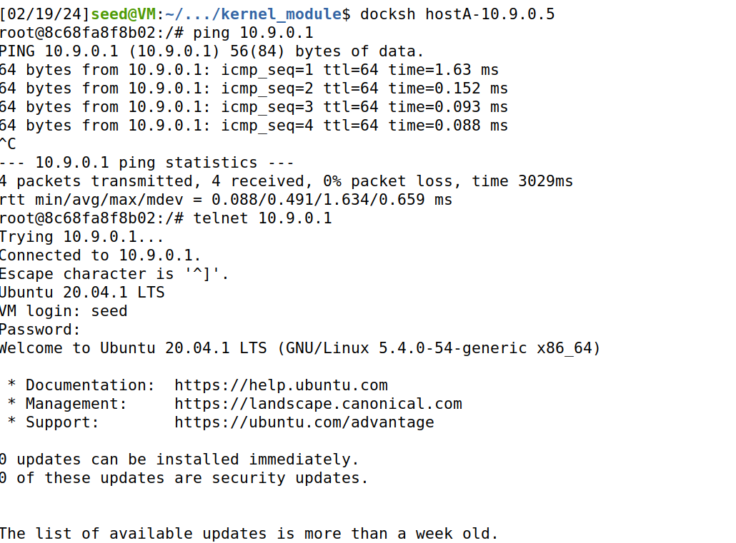

Then, we use **make** command to build the modules and check them using ls commands, now we insert module using **insmod seedBlock.ko** command. Then we find (seedBlock: Registering filters) is displayed in message.

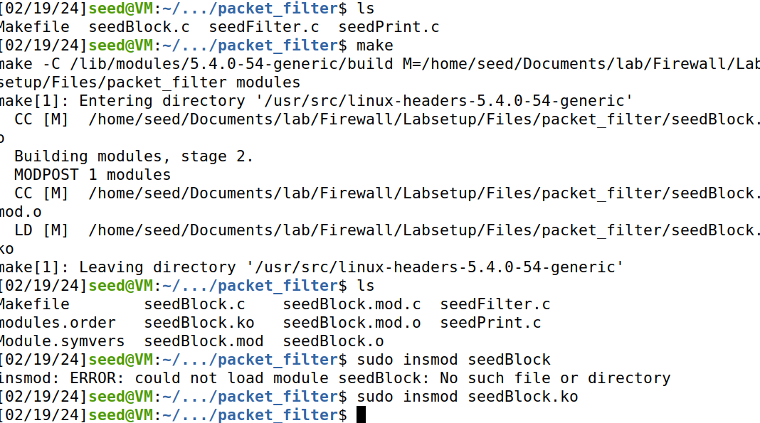

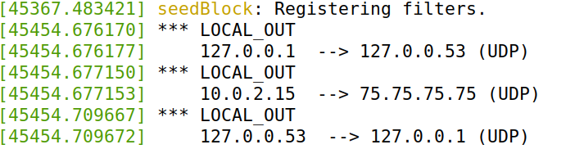

**3.1 Prevent other computers to ping the VM**

We are implementing the first hook

Now we are going inside the host machine A and try to ping to 10.9.0.1

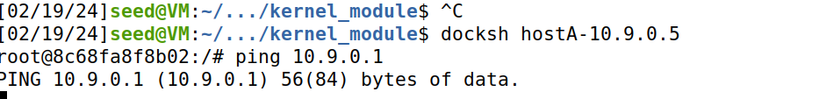

Then we are getting this message with dropping destination 10.9.0.1(ICMP)

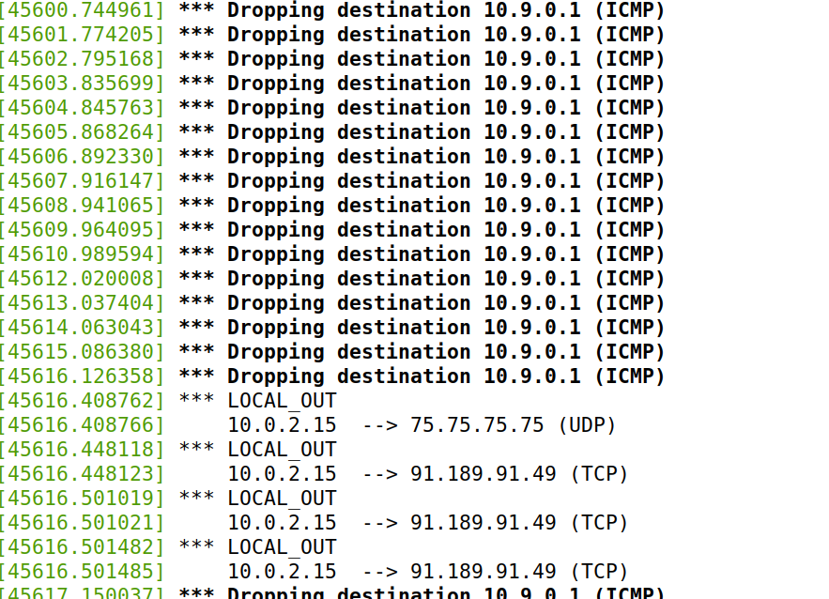

**3.2 prevent other computers to telnet into the VM**

For Next hook, Similarly now we telnet 10.9.0.1 in host machine

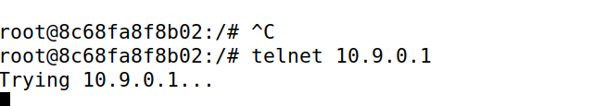

Message got after telnet. Dropping destination 10.9.0.1(TCP), destination port 23.

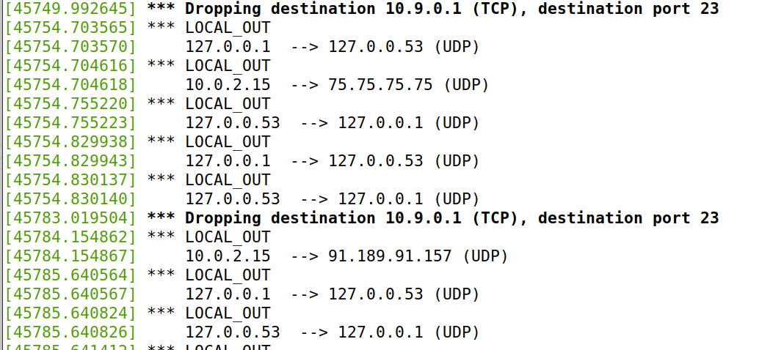

Finally the module is removed and the message is displayed.





**Task 2 Experimenting with Stateless Firewall Rules – 60 pts**

Now while running **iptables -t nat -L -n ,** List all the rules in a table (without line number)

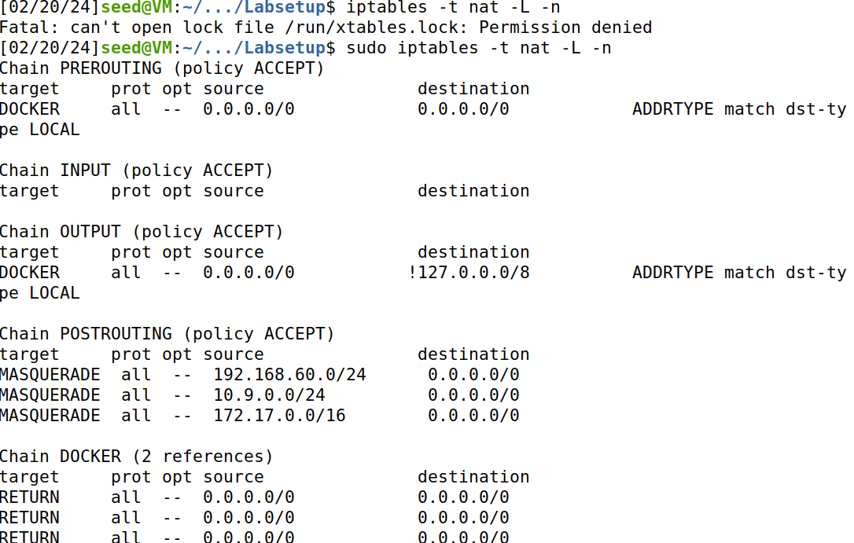

Now while running **iptables -t filter -L -n --line-numbers** , List all the rules in a table (with line number)

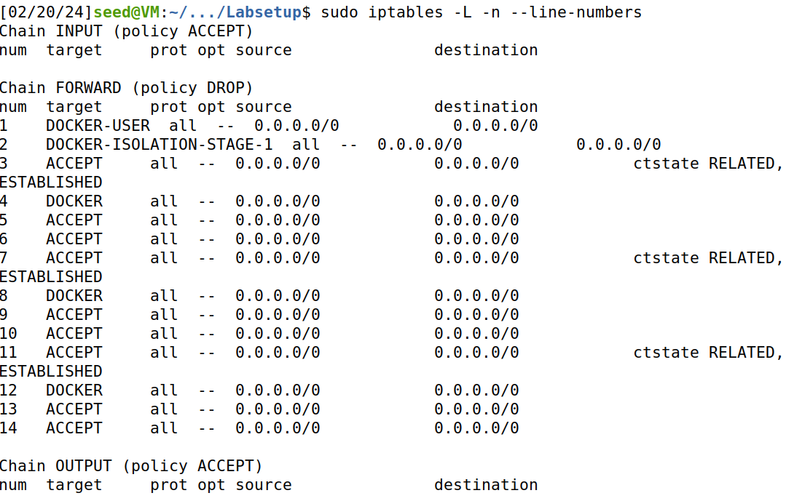

Now we run the commands in docker host A container, when I run **iptables -t filter -L -n**, it lists all empty target, opt source and destination. When I run **iptables -t nat -L -n**, it lists alltarget,opt source, destination for chain Prerouting, INPUT, output, Postrouting, and others.

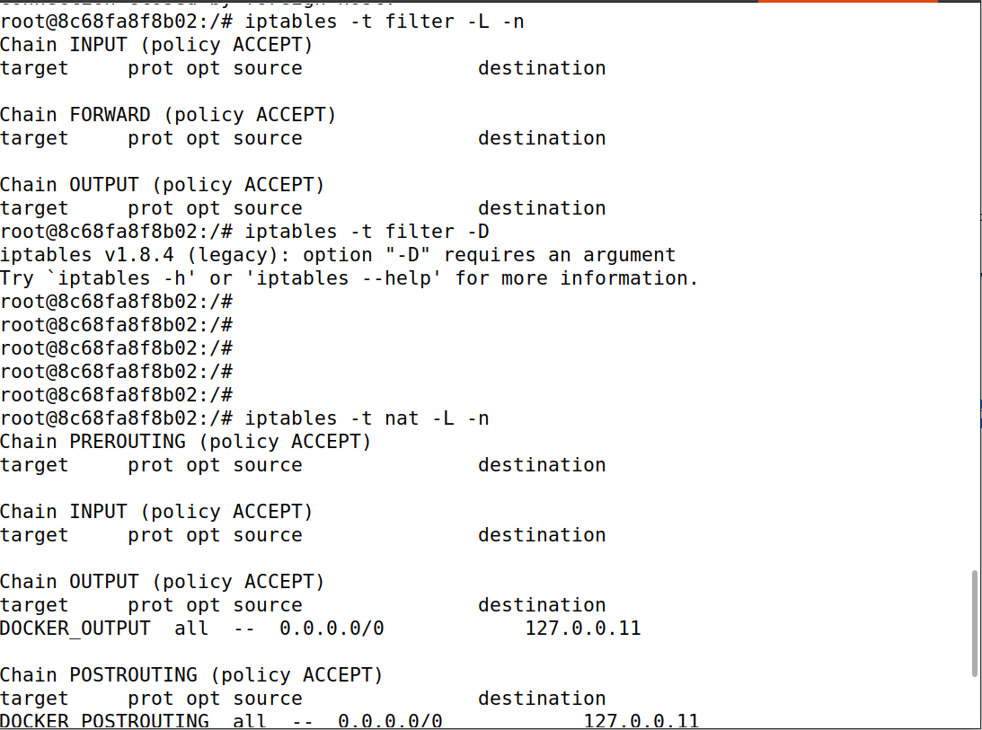

**Task 2.A Protecting the Router – 10 pts**

In seed-router container we find the ip address using ip addr.

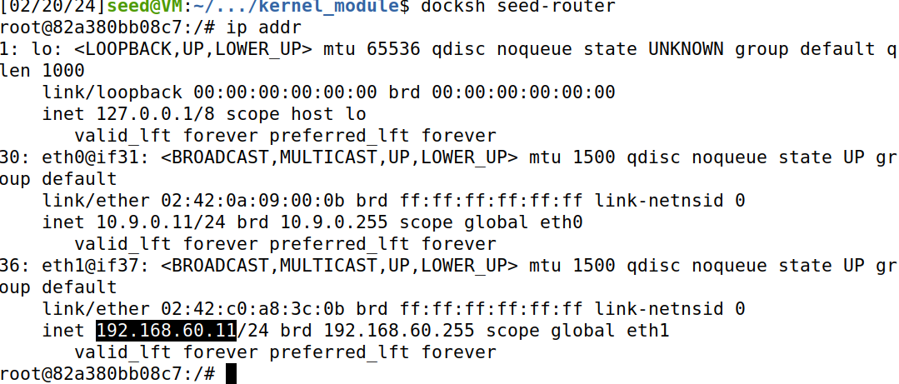

We are trying to ping the seed routers two ip address 10.9.0.11 and 192.168.68.11 inside the host A.

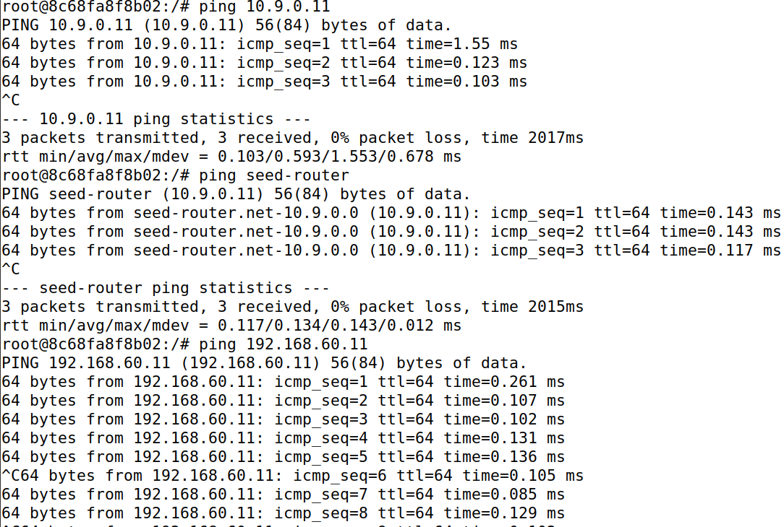

We are trying to telnet the seed routers’ two ip addresses inside the host A.

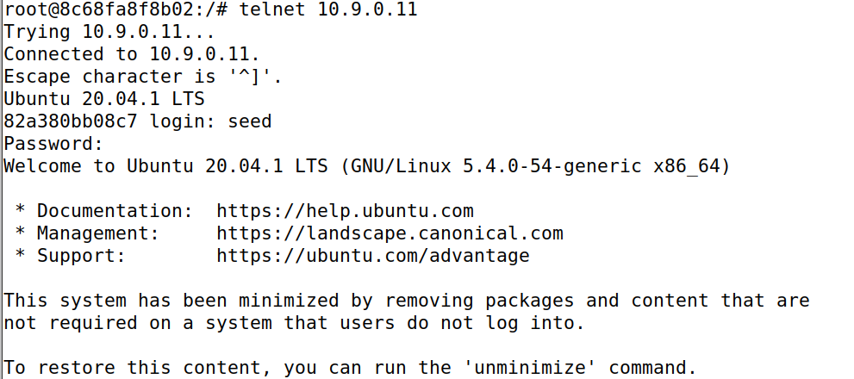

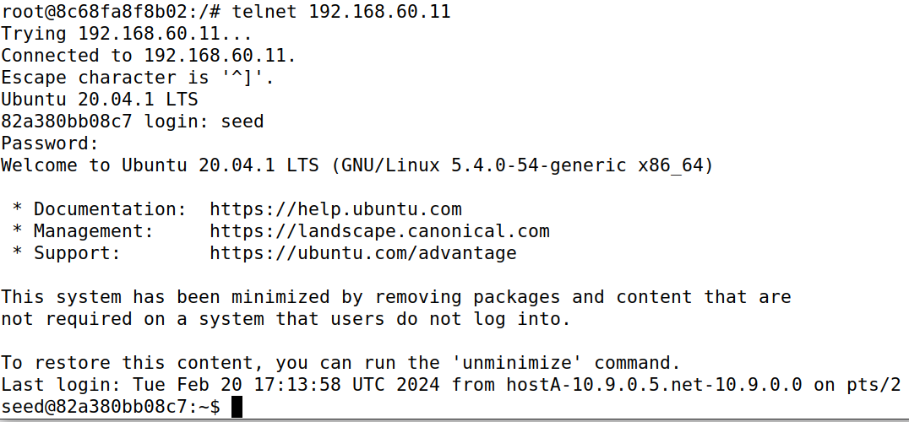

Now, we will set up rules in the seed router

First we check whether the filter is empty or not with this command **iptables -t filter -L -n,** we find there is no entries and then after running **iptables -A INPUT -p icmp --icmp-type echo-request -j ACCEPT**, we find that This iptables rule permits incoming ICMP (ping) requests (type 8) from any source to any destination with the INPUT chain's default policy set to ACCEPT.

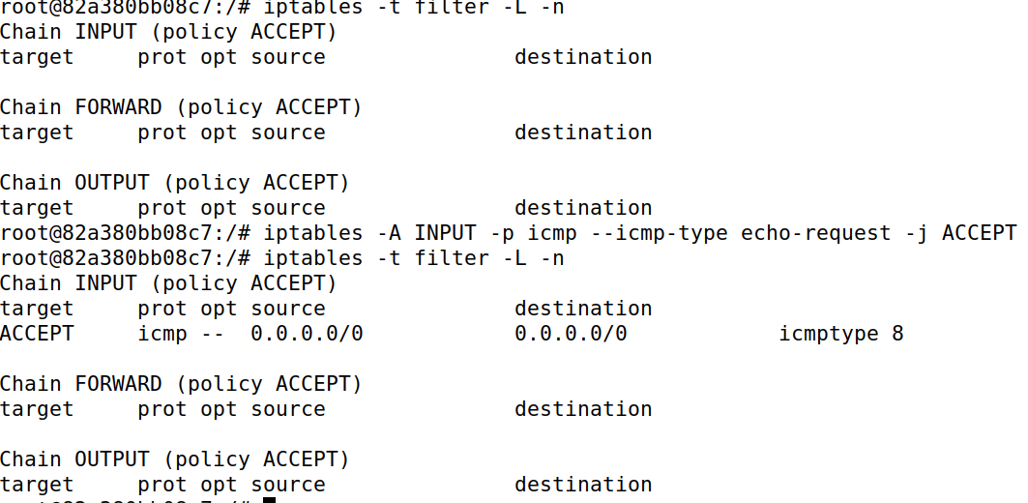

Now, we run other rules, allow incoming ICMP echo-reply packets and block all outgoing traffic by default, while also blocking all incoming traffic except for ICMP echo (ping) requests and responses.

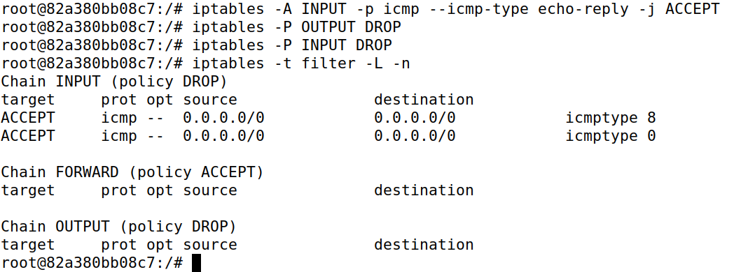

**(1) Can you ping the router?**

Now we ping 192.168.60.11 in the Host A container,ping is not working. The ping command isn't receiving any responses from the destination IP address (192.168.60.11), indicating that the ICMP echo-reply packets are likely being blocked by the firewall rules configured with iptables.

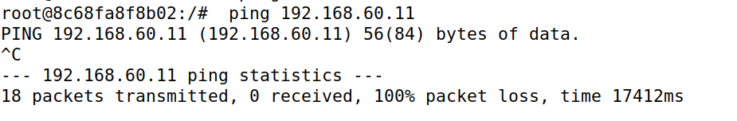

**(2) Can you telnet into the router**

Now we telnet 10.9.0.11 in the Host A container, telnet is not working and we are not able to find any new messages in kernel buffer

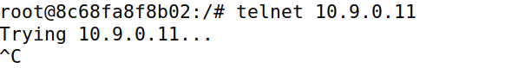

Before moving on to the next task, we restore the filter table to its original state by running the following commands:

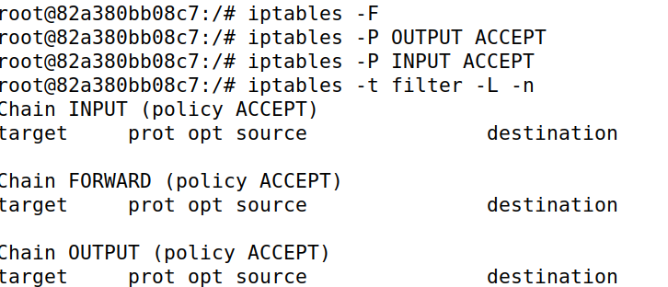

**Task 2.B Protecting the Internal Network – 20 pts**

In seed router , we run **iptables -L -n** and check about list empty now we run **iptables -A FORWARD -p icmp --icmp-type echo-request -j DROP** and find The iptables command you ran successfully added a rule to the FORWARD chain, which drops incoming ICMP echo-request packets (**--icmp-type 8**) on the **eth0** interface.

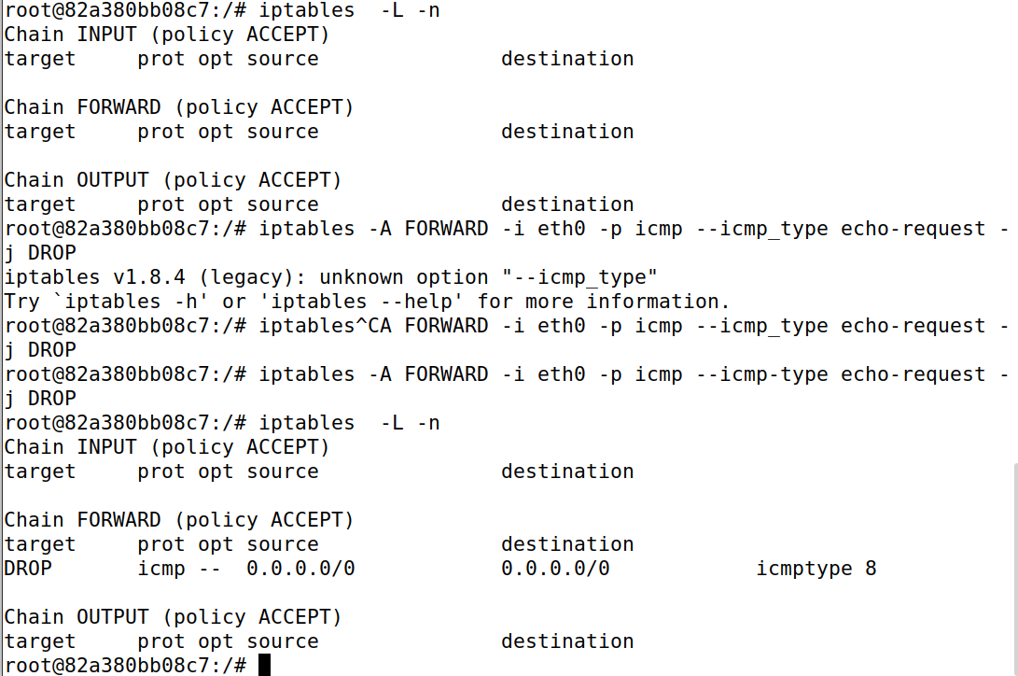

**1. Outside hosts cannot ping internal hosts.**

Now we are trying to ping the internal host(192.168.60.5)from **host A** which is an outside host. But it is a failure.

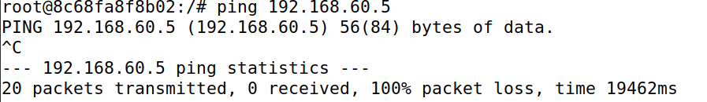

**2. Outside hosts can ping the router.**

Now we are trying to ping the router(10.9.0.11)from **host A** which is an outside host. But it is a success.

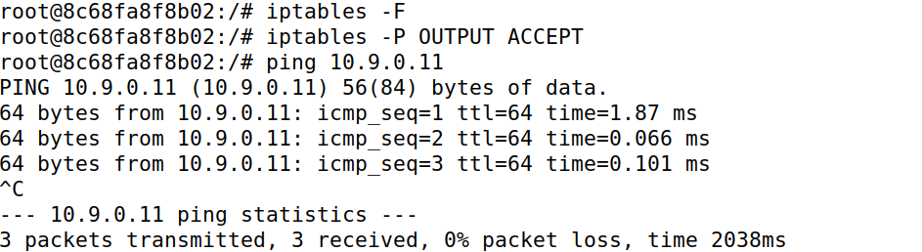

**3. Internal hosts can ping outside hosts.**

Now we are trying to ping the outside host(10.9.0.5)from **host 1** which is an internal host. But it is a success.

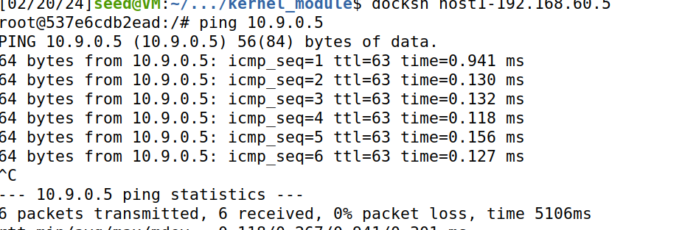

**4. All other packets between the internal and external networks should be blocked.**

When iptables **-A FORWARD -p icmp --icmp-type echo-request -j DROP** is entered,When listing the iptables rules (iptables -L -n), we can see rule under the FORWARD chain.

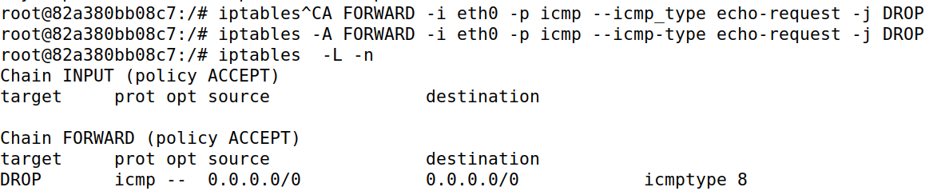

Now we are entering the rules like **iptables -A FORWARD -i eth1 -p icmp --icmp-type echo-request -j ACCEPT, iptables -A FORWARD -i eth0 -p icmp --icmp-type echo-reply -j ACCEPT, iptables -P FORWARD DROP.** Additionally, when listing the rules with verbose output **(iptables -L -n -v)**, we can see packet and byte counters for each rule, which indicate the number of packets and bytes that have matched each rule since it was last reset.

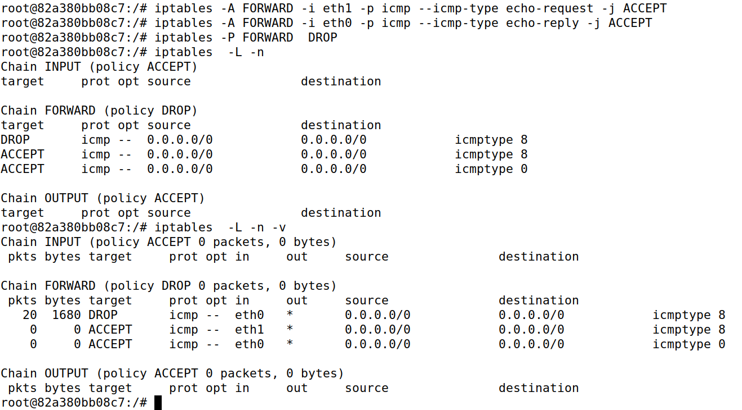

From Outside host A we are pinging the inside host h1. This doesn’t happen .No it is not successful. Later we are telnet inside host h1 ,but not able to connect.

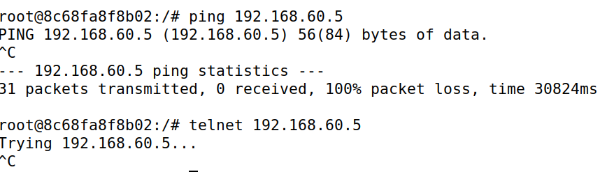

From inside host1 we are pinging outside host hA(10.9.0.5). While telnet 10.9.0.5, it is not able to connect to it.

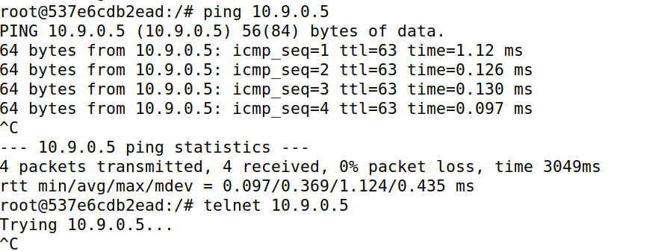

This shows all other packets between the internal and external networks are blocked.

**Task 2.C Protecting Internal Servers – 30 pts**

1. **All the internal hosts run a telnet server (listening to port 23).**

host1(internal host) run a telnet server.

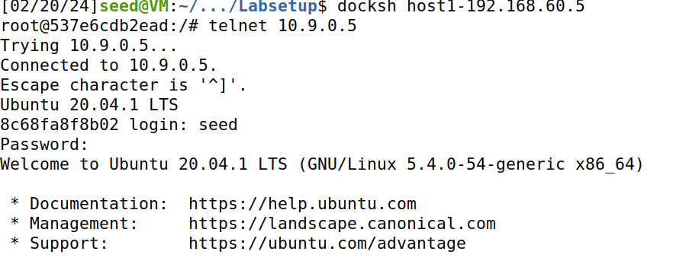

**Outside hosts can only access the telnet server on 192.168.60.5, not the other internal hosts.**

These are iprules entered on the seed attacker for this problem.

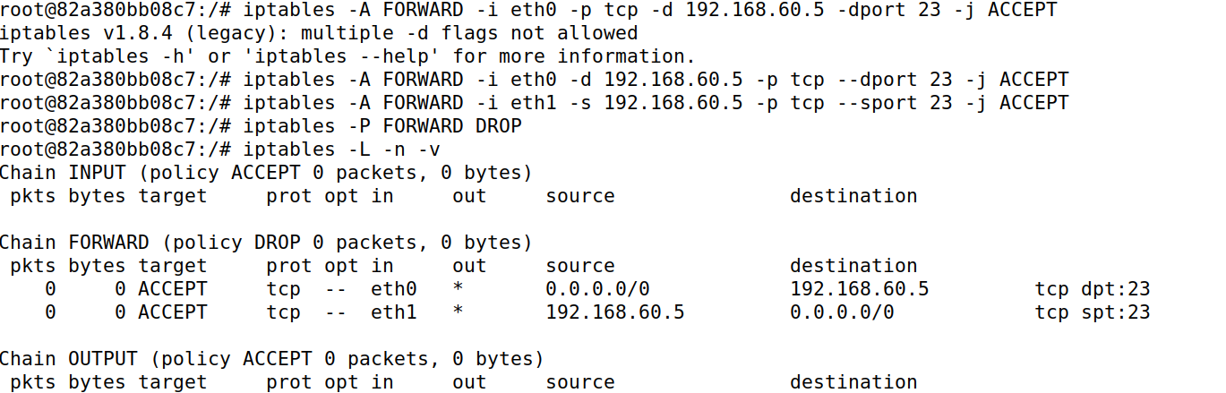

Now we are in outside host A- 10.9.0.5 trying to access host 3(telnet 192.168.60.7),host 2(telnet 192.168.60.6) but it failed.

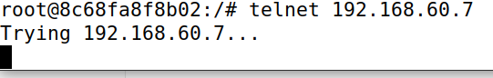

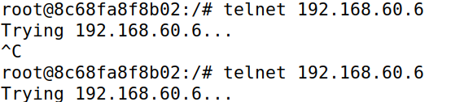

But while accessing host1 which is 192.168.68.5 it is successful.

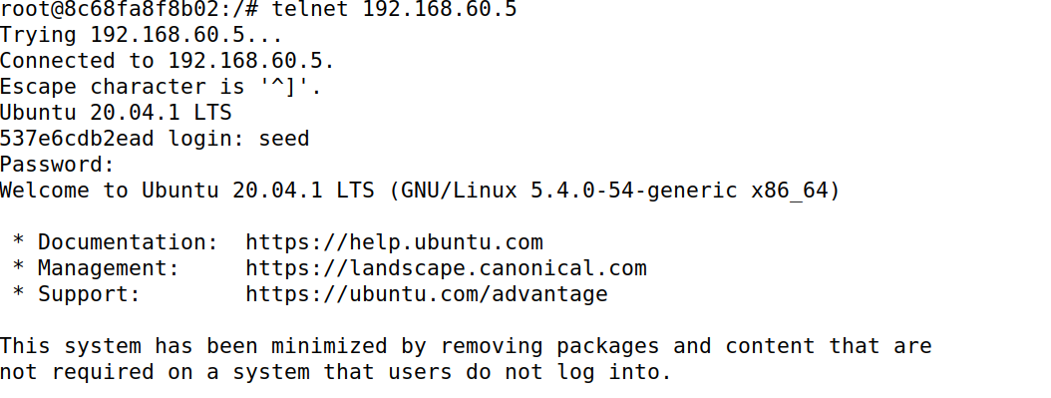

2. **Outside hosts cannot access other internal servers.**

Now we trying connect outside hosts with internal server through net cat but it failed. We tried in both udp and tcp

Now we are trying to access host 1 from host A

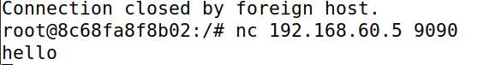

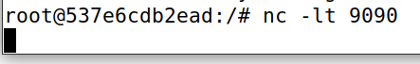



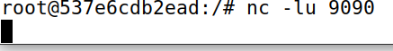

**3. Internal hosts can access all the internal servers.**

We are able to access all internal servers from the internal host.

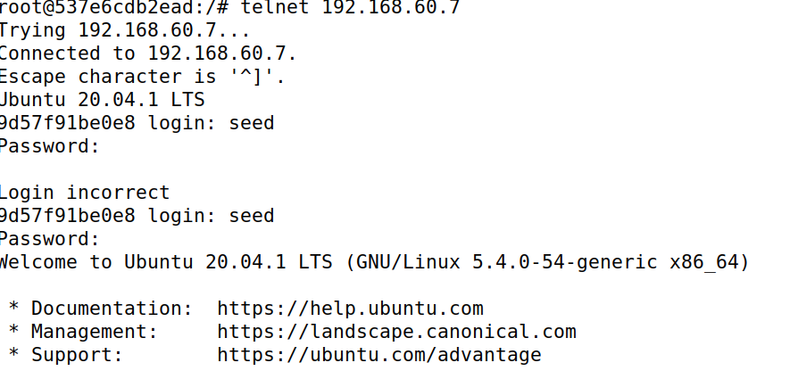

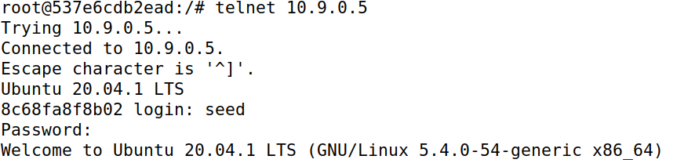

Now we are establishing netcat tcp connection between host1 and host2

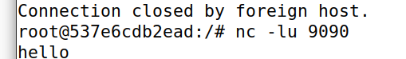

When I type hello in host 2 it is displayed in host 1 which shows, internal host can access internal server.

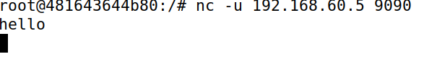

establishing netcat udp connection between host1 and host2

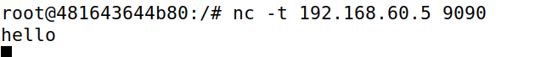

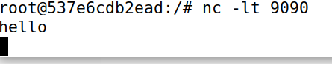

**4. Internal hosts cannot access external servers.**

Now we are connecting host A (outside) to internal host2 through netcat tcp but host A is not able to listen to host 2

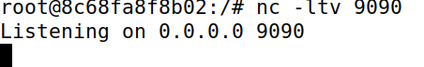

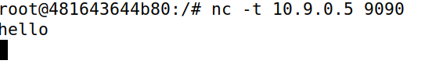

So it is proved that internal hosts cannot access external servers.

5. In this task, the connection tracking mechanism is not allowed. It will be used in a later task**.**

NO connection tracking mechanism is used.

**Task 3 : Connection Tracking and Stateful Firewall – 40 pts**

To support stateful firewalls, we need to be able to track connections. This is achieved by the conntrack mechanism inside the kernel.

**Task 3.A Experiment with the Connection Tracking – 15 pts**

**ICMP Experiment:**

We are doing these processes in the seed router.

Before we use conntrack -L and check whether there are no entries at the beginning. Then we ping 192.168.68.5&

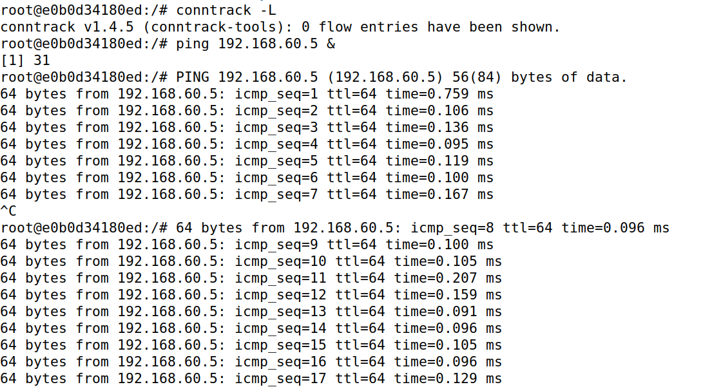

Now While we are checking by **contrack -L**, there are 1 entries shown , after killing the job, 0 entries are shown.

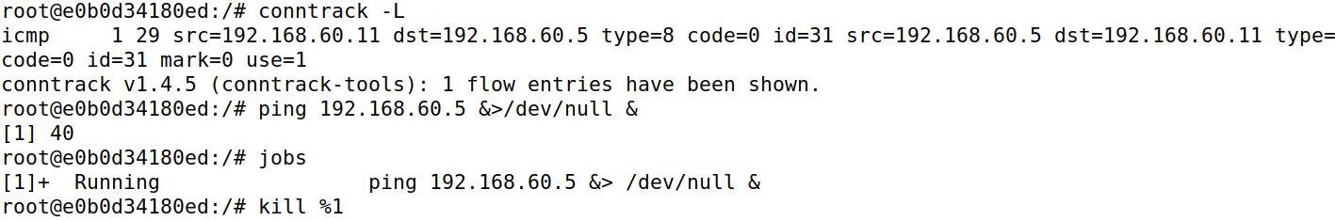



It took me 30 seconds to keep the ICMP connection state kept even after running the kill command.

**UDP Experiment:**

Now we are establishing netcat udp connection between hostA and host 1 and then we check by entering hello.

Below happens in host1 and host A respectively:

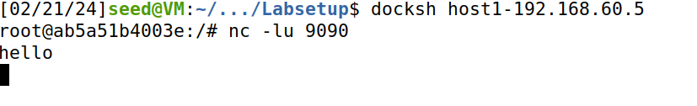

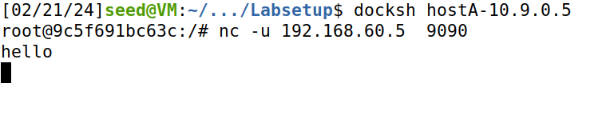

Now we conntrack and find existing entries and we are checking how long does the connection lasts.

(unfortunately I am not able to stop this icmp, it is coming automatically and not able to kill or stop it.)

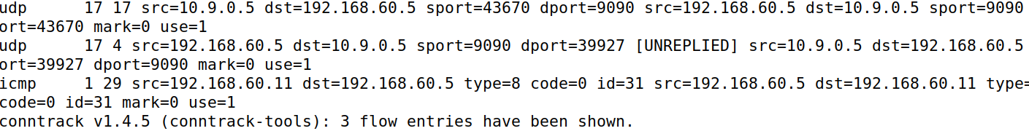



It takes 15 seconds for me in UDP connection

**TCP Experiment:**

Now we are establishing tcp connection (netcat) between host1 and host A and we enter hello and check it on other host.

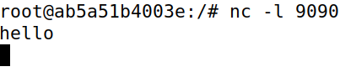

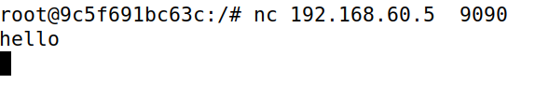

Now we are able to find out tcp packet here while running **conntrack -L** in router

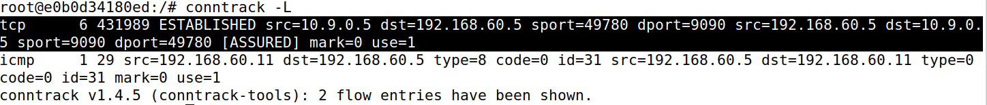

It took me 20 seconds to end the connection



**Task 3.B Setting Up a Stateful Firewall – 25 pts**

We enter the rules, then we check iptables. We are running these on seed-attacker.

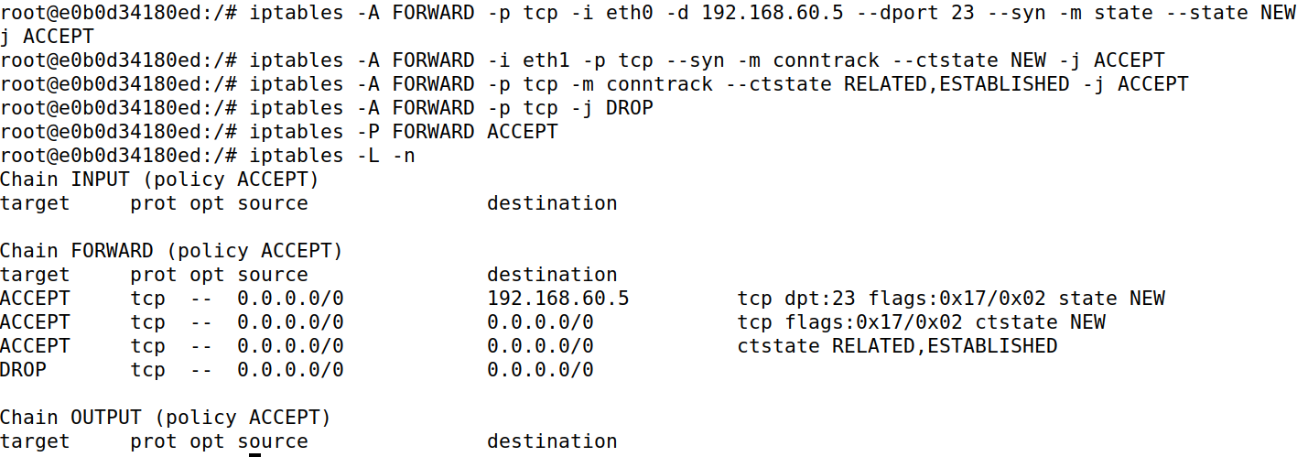

Inside host 1, we telnet 10.9.0.5 to host A, it is successful

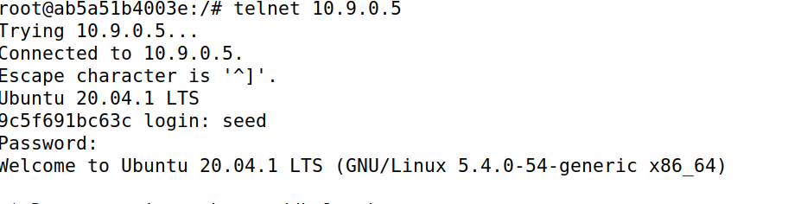

But I cannot telnet to host 2 from hostA

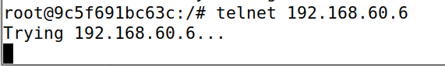

In hostA, we telnet to host 1, it is successful.

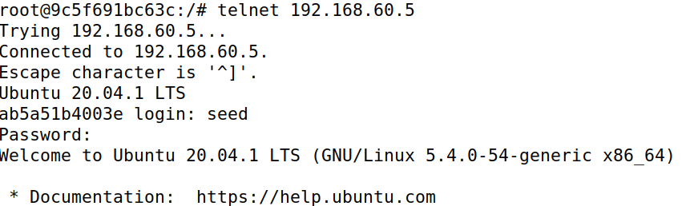

Now we are establishing a netcat connection between hostA and host1, but host1 is not able to listen to host A.

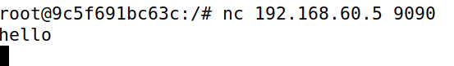

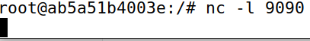

But netcat udp connection between hostA and host1 are successful.

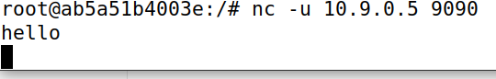

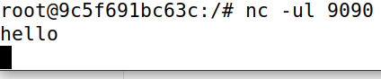

Based on these two sets of rules, compare these two different approaches, and explain the advantage and disadvantage of each approach.

**Advantages of conntrack rule:**

Conntack will work as expected

**Disadvantages of conntrack:**

It consumes more resources to keep connections.

We add new rules and list iptables.sets the default policy for FORWARD chain to ACCEPT, allowing all forwarding traffic. The first command sets the default policy for FORWARD chain to ACCEPT, allowing all forwarding traffic and . Subsequent commands add rules to ACCEPT TCP traffic destined for port 23 (SSH) on IP address 192.168.60.5, while dropping TCP packets with the SYN flag set for other destinations.

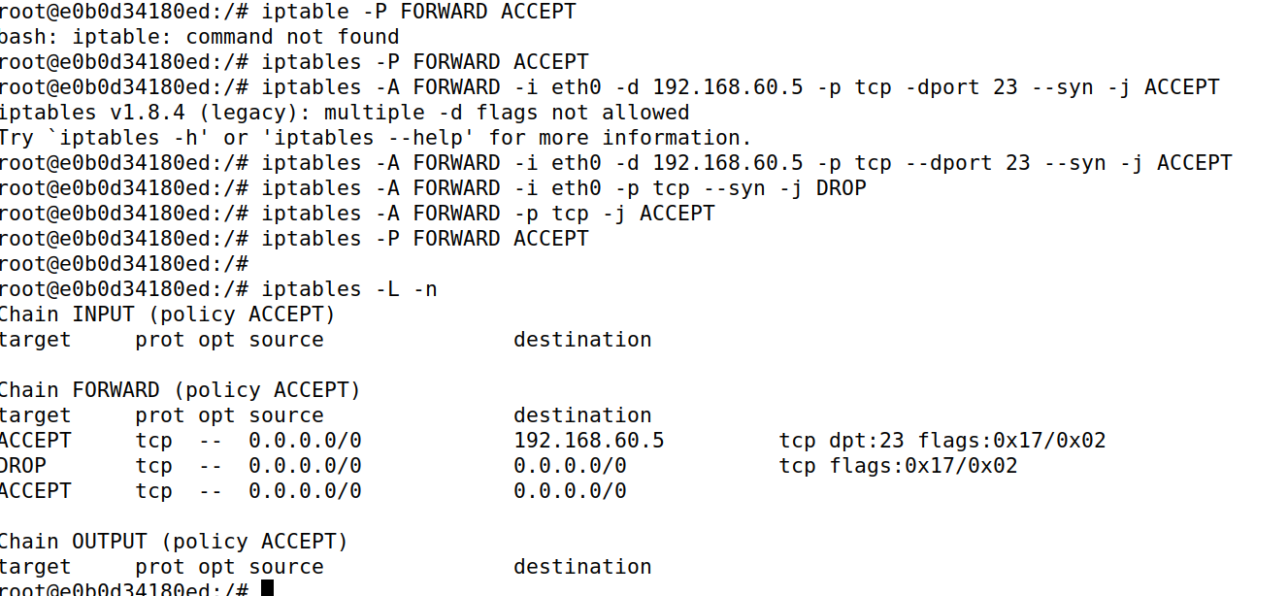

Now in host A, we try to set up a telnet connection in hostA ,telnet to host2 is not successful but telnet to host 1 is successful.

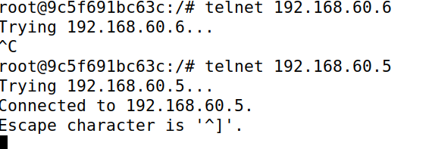

Now in host1, we telnet 10.9.0.5 which is successful

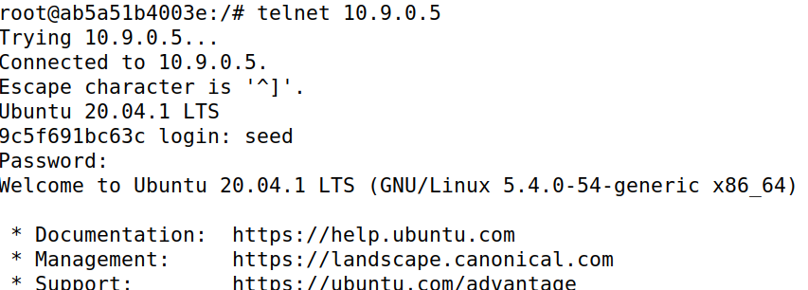

**Advantages of Second Rule:**

It consumes less resources

**Advantages of Second Rule:**

It could get stimulated results.

So we did it without a connection tracking mechanism.

**Task 4 : Limiting Network Traffic – 10 pts**

The command **iptables -m limit -h** displays help information for the limit module in iptables, which is used to limit the rate at which packets are matched.

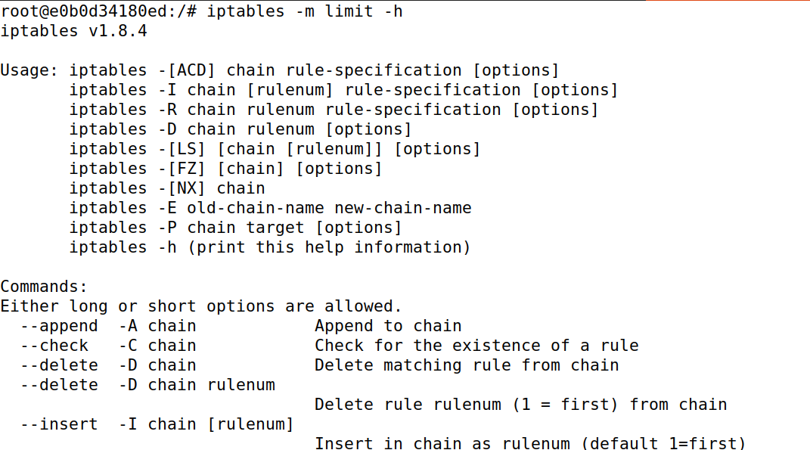

Now if we run the rule in seed-attacker and ping hostA (10.9.0.5) from host1.I is working. This shows that rule 1 is useless.



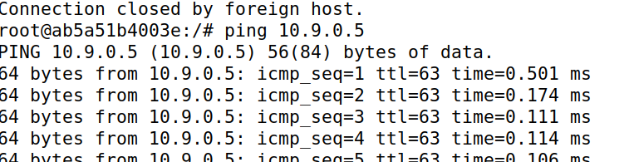

Now we add line 2, **iptables -A FORWARD -s 10.9.0.5 -j DROP** in the router, afterwards it takes 10 seconds for me for packets . so it means that the 1st line work along the 2nd line.

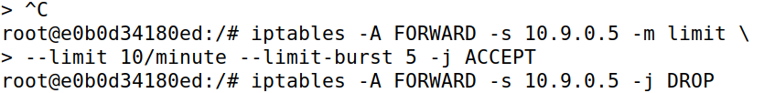

In host 1, we are pinging hostA.

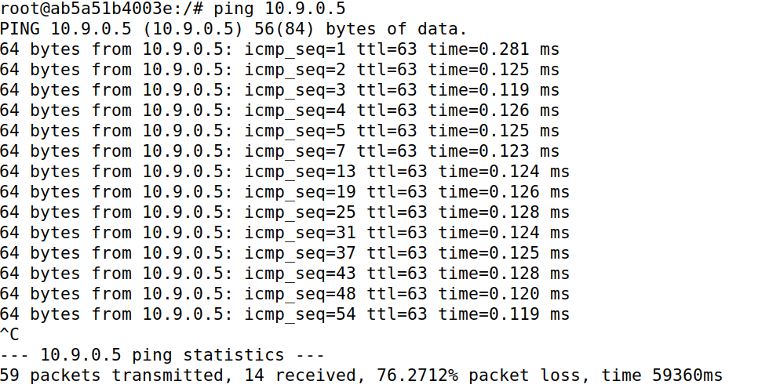

So, we limited the number of packets that can pass through the firewall.

**Task 5 Load Balancing – 30 pts**

**Using the nth mode (round-robin).**

Initially we run net cat udp command **nc -luk 8080** on host1, host2, host3 below respectively.

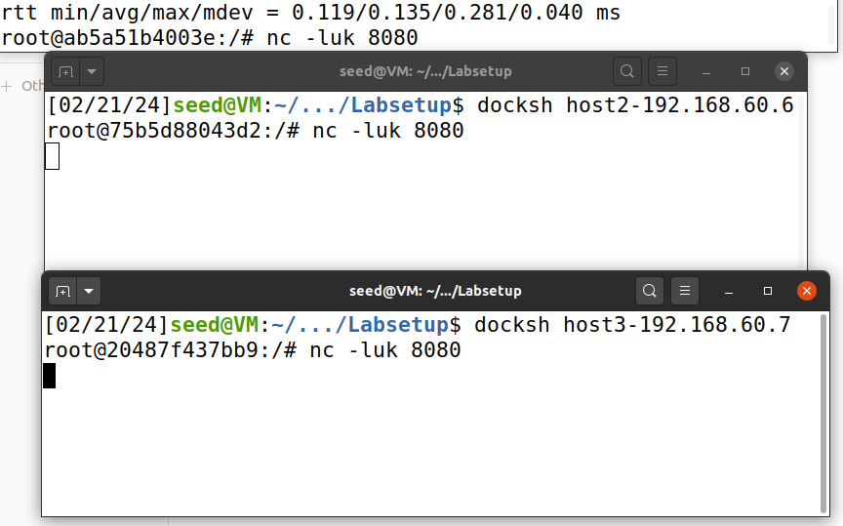

Then I run the following command on the seed router. This iptables command forwards every third UDP packet arriving at port 8080 to the destination IP address 192.168.60.5 on port 8080, utilizing the NAT table's PREROUTING chain.

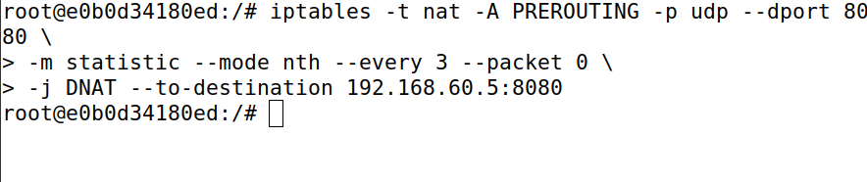

**Left 3 tabs are host1,2,3 and the right tabs are host A and attacker respectively.** Now i we type **echo hello | nc -u 10.9.0.11 8080** in host A and the hello message is reflected in host1 which is on the left side.

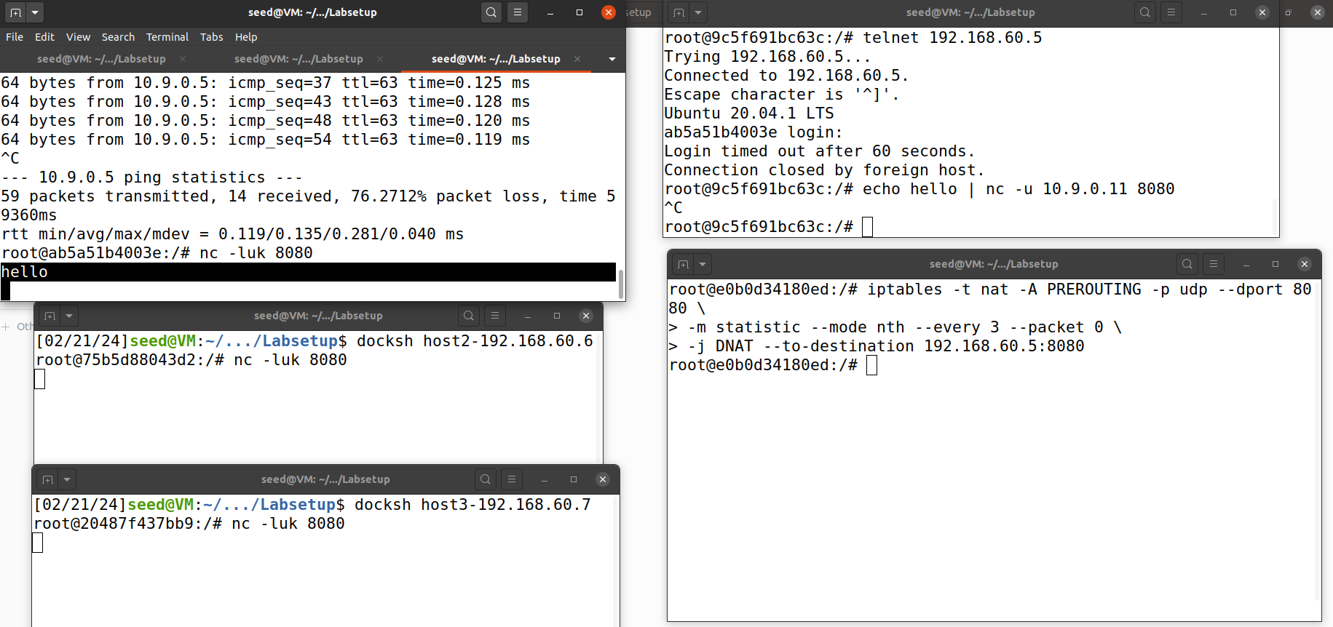

**Then**, I enter this on the host A and I replace values like every 1,2,3 like that in the rule.



When we enter **iptables -t nat -L -n**, we can see about the details of netcat connection established before.

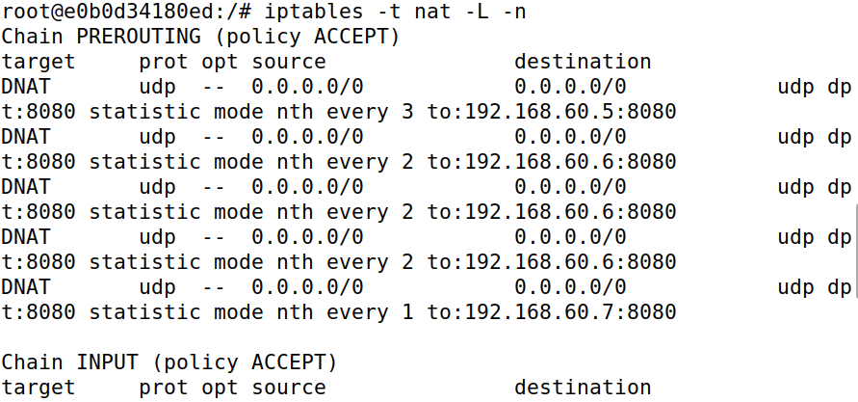

Left 3 tabs are host1,2,3 and the right tabs are host A and attacker respectively. Now we are running **echo hello | nc -u 10.9.0.11 8080** on **hostA,** we replace **hello** with **hello1, hello2, hello3** and we can find it on **hostA, hostB**

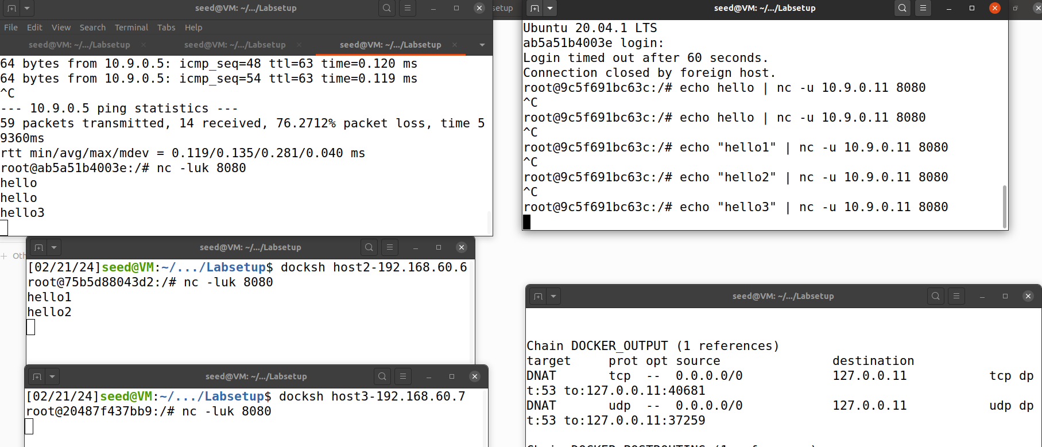

Similarly when I type hi1,hi2,hi3,hi4 on host Ait is reflected on host1.

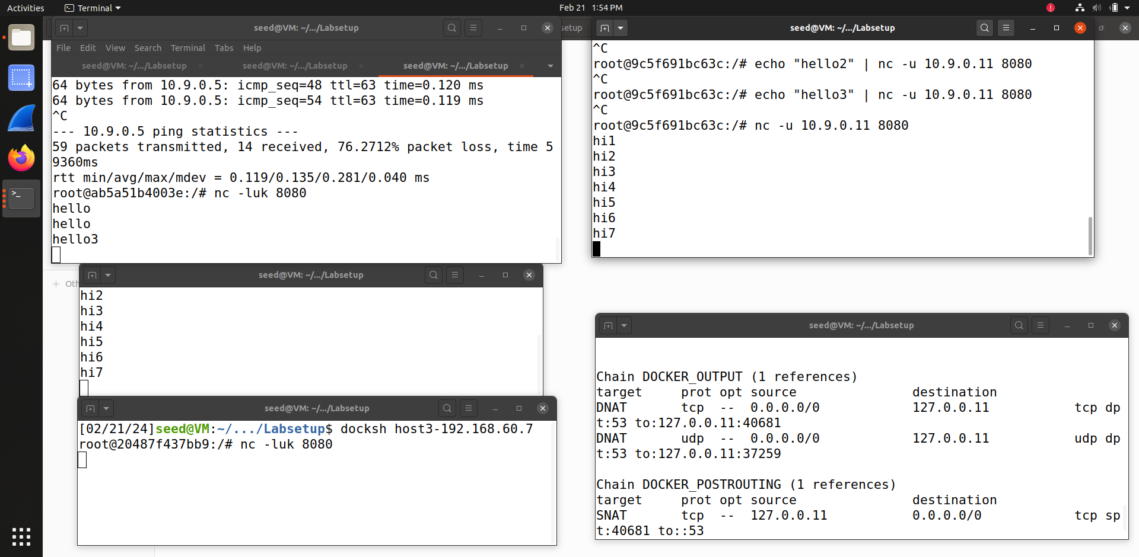

These will help to clear the previous connection details and once again we check it by listing iptable.

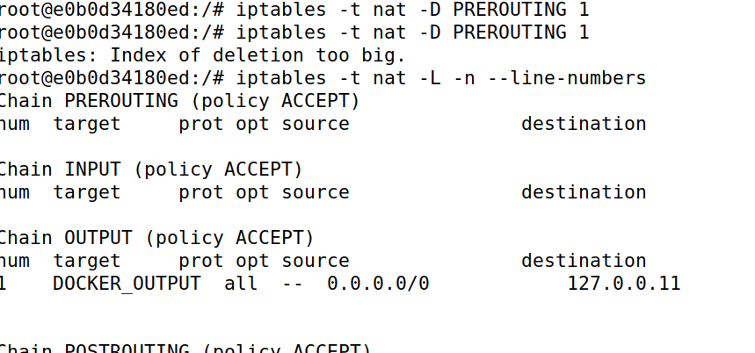

**Using the random mode:**

Here we run the rule **iptables -t nat -A PREROUTING -p udp --dport 8080 \ -m statistic --mode random --probability P \ -j DNAT --to-destination 192.168.60.5:8080** and we replace PROBABILITY with values like 0.5, 1 and 0.333.While listing we can see target, opt source, destination.

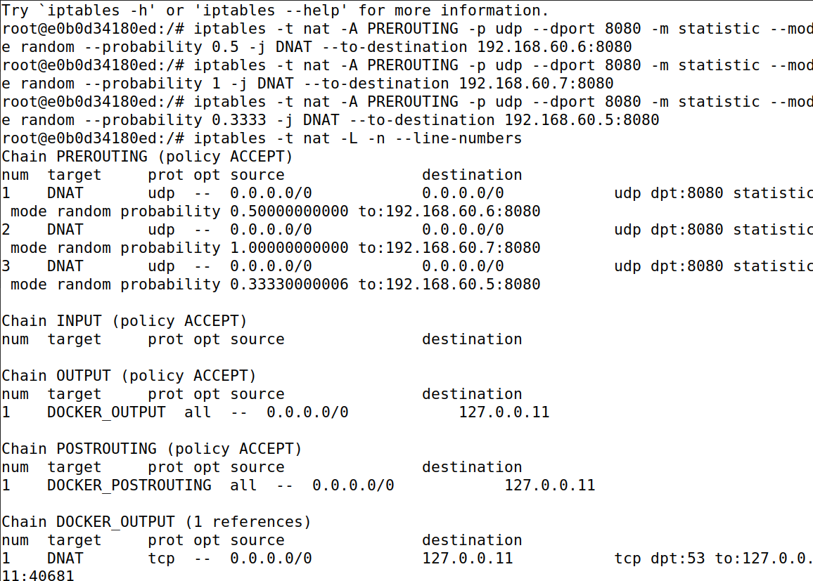

We already set up a netcat udp connection between seed-attacker, hostA, host1, host2, host3. Then,

**Left 3 tabs are host1,2,3 and the right tabs are host A and attacker respectively.**

Now i we type **echo ‘aha1’ | nc -u 10.9.0.11 8080** similarly aha2, aha3, aha4 and aha5, aha6, aha7 in host A and **aha** message is reflected in host2 and host3. Which is randomly received.

